***Sprint#2 design:***

In this section, we will introduce the detailed design for the sprint, including the architecture and components among them, and also the database components.

* 1. Component diagram

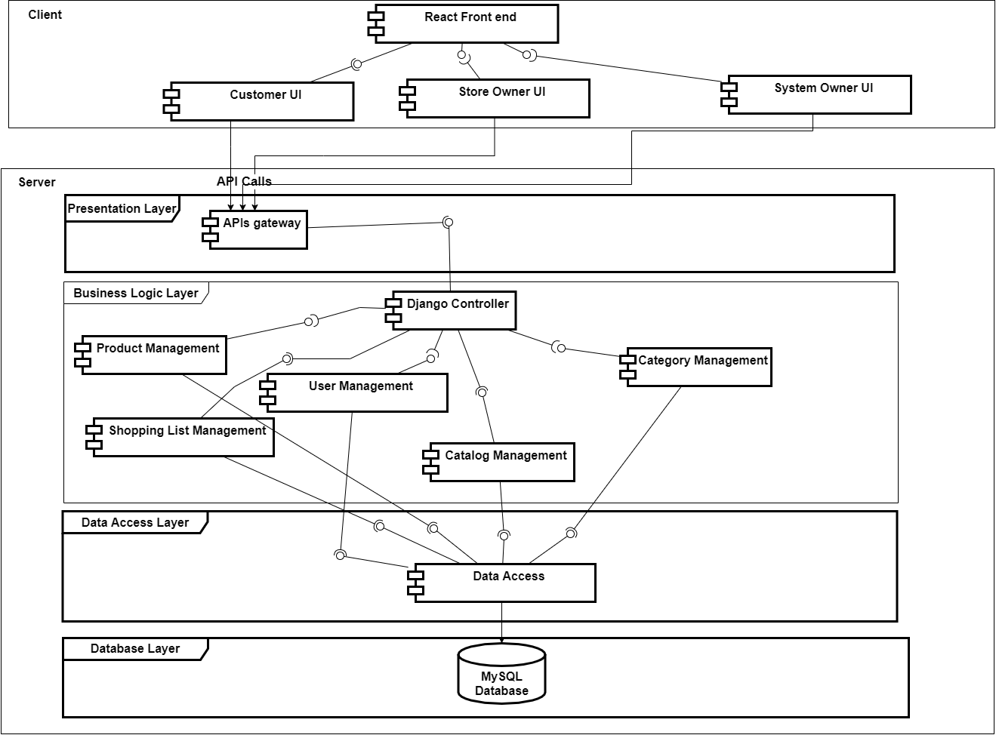

*Figure 28 Sprint#2 Component diagram*

* 1. Detailed class diagram

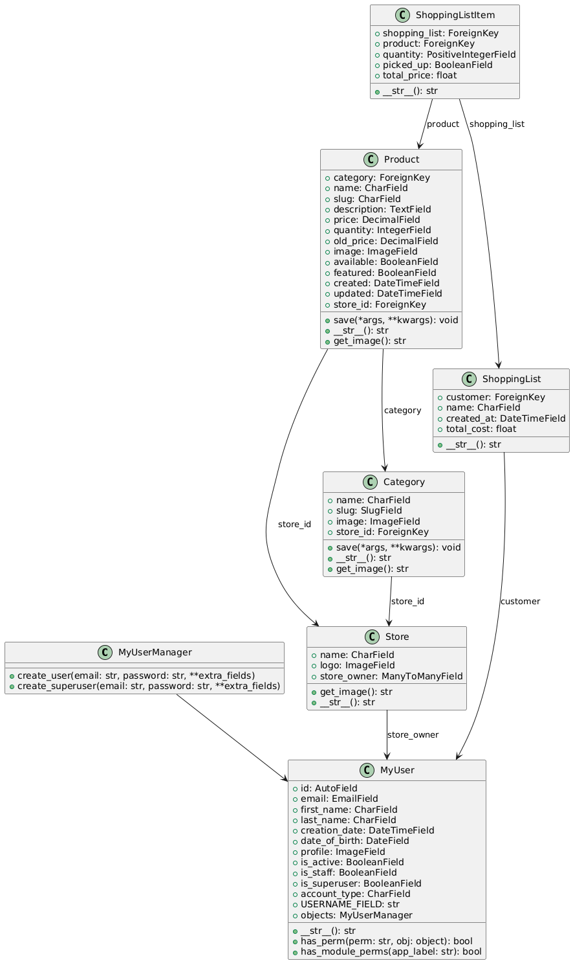

*Figure 29 model class*

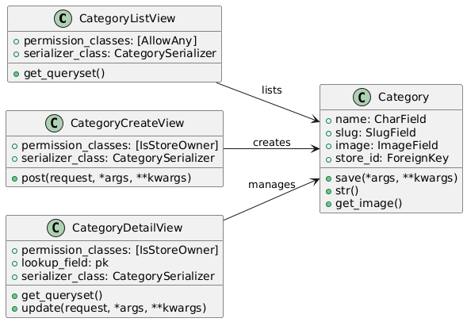

*Figure 30 category mgmt. - views classes*

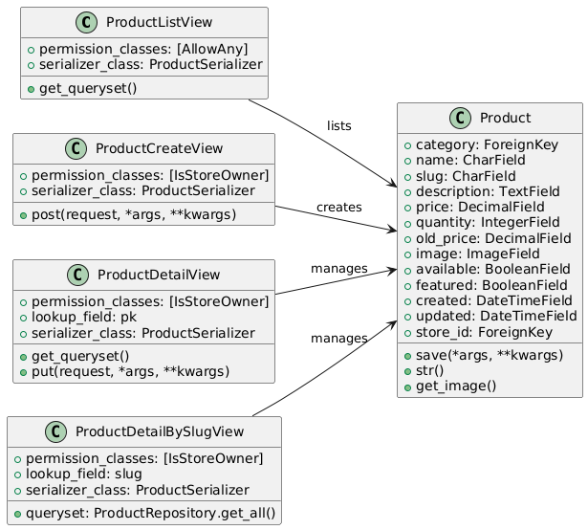

*Figure 31 product mgmt. - views classes*

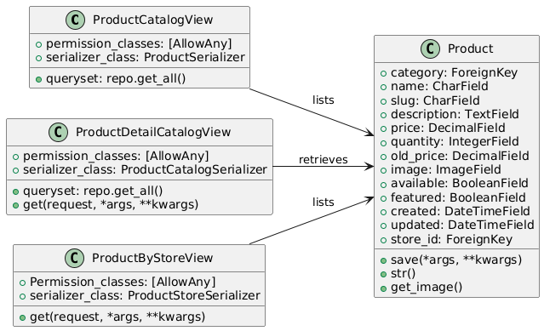

*Figure 32 catalog product. - views classes*

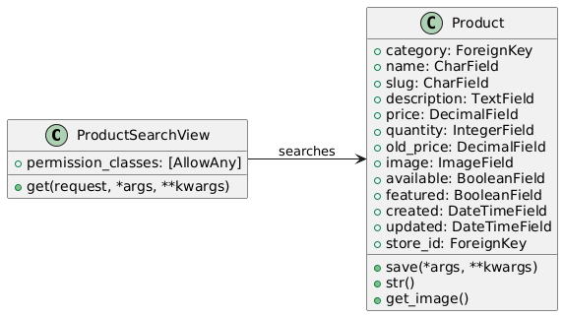

*Figure 33 search product. - views classes*

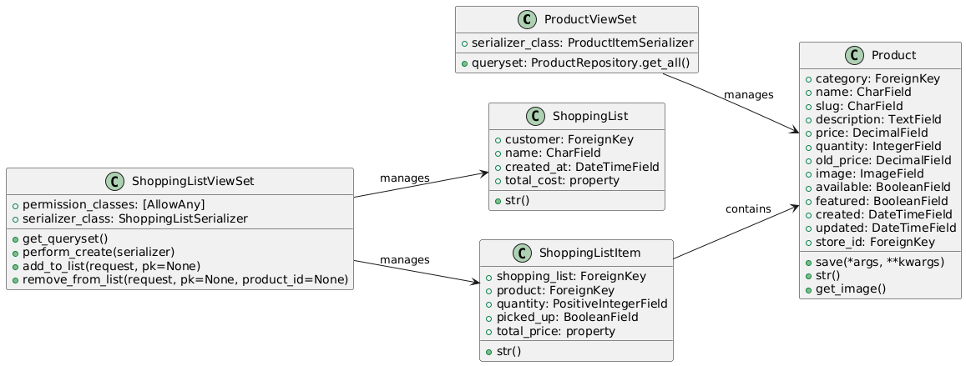

*Figure 34 shopping list mgmt. - views classes*

* 1. ER diagram

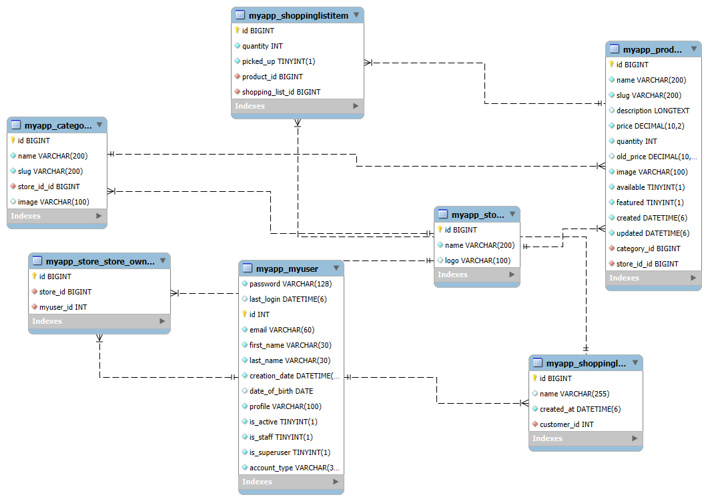

*Figure 35 sprint#2 er-diagram*